Lesson 30 – Functional Decomposition
By Dr. Steve Hadfield

In previous lessons, you have learned about process abstraction where a part of an algorithm or computer program can be separated out from the rest and given a name representing the “process” that it performs. To run that process you simply call it by name. The details of how that process is accomplished have been “abstracted” away.

The routines from RAPTORGraph that we have been using for awhile now are a form of process abstraction. When we need to draw a box on the graphics screen, we simply call Draw_Box and we get our box drawn. The details of how RAPTOR actually draws the box have been abstracted away.

By abstracting away the details of the process, we have a natural tool for handling complexity in algorithms. Specifically, we can break our algorithm into sub-processes, design the sub-processes separately, and simply call them to run when we need them. It’s a lot like cutting your food into manageable pieces and eating them individually (Yes, your mother was very wise wasn’t she).

Functional Decomposition

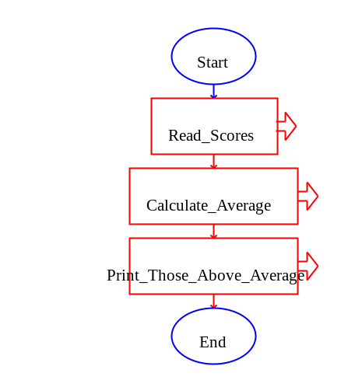
This leads us to the concept of functional decomposition. With this concept, we think of a program that we need to write as one big process that does some function. We design that process by writing an algorithm that calls a number of sub-processes that each do some part of the overall function. At this point we don’t care how these sub-processes do their piece of the job. Rather, we simply assume they will be able to do their job and we will figure out how they will do that later on. In this way, we have decomposed a big function (problem to solve) into a series of smaller functions (problems) which will each be easier to develop. We then do the exact same thing with each of the smaller functions by looking at them in isolation and breaking them down into even smaller functions. Eventually we get to a point where we can implement the smaller functions directly in the programming language (RAPTOR in our case).

A Simple Example

Let’s look at a simple example of how this might work. Say we have been asked to write a program that reads in a bunch of scores and prints out all of the scores that are over the average. At this high-level, we need to do three things: read in the scores, calculate the average, and print each score over the average. This results in the top-level function shown to the right.

Now we take each of these smaller functions and develop their logic separately. Let’s start with Read_Scores as we'll need this to work before we can do very much on the rest of the functions. Read_Scores is fairly simple and can be directly implemented without having to decompose it into smaller pieces. Below is a subchart that will read one or more values into an array called Score[].

Read_Scores
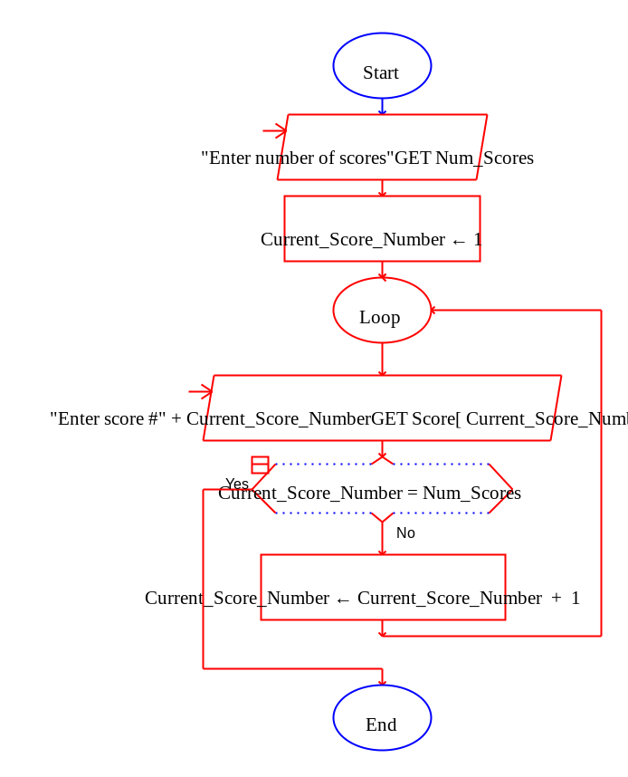

That wasn’t too bad; only six symbols total. Let’s do the same thing for each of the other two sub-processes. (See the subcharts on the next page.)

At this point, you are probably saying, “Duh…” and you’d be exactly right. All we are doing is formalizing a very intuitive concept that you’ve likely been using for quite awhile. The big difference is that we are now decomposing the functions very formally and explicitly. Yet it can be very important to be formal and explicit; especially when we have to communicate the process to other human beings. The more explicit we are, the less chance there is for misinterpretations.

Calculate_Average_Score  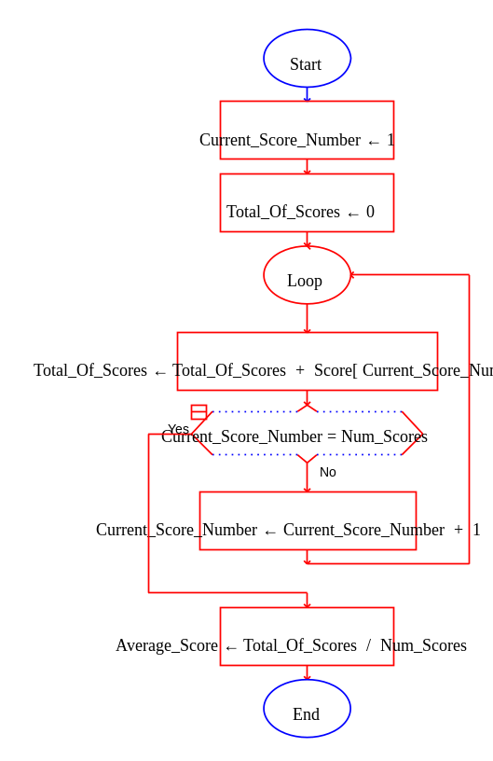 | Print_Those_Above_Average  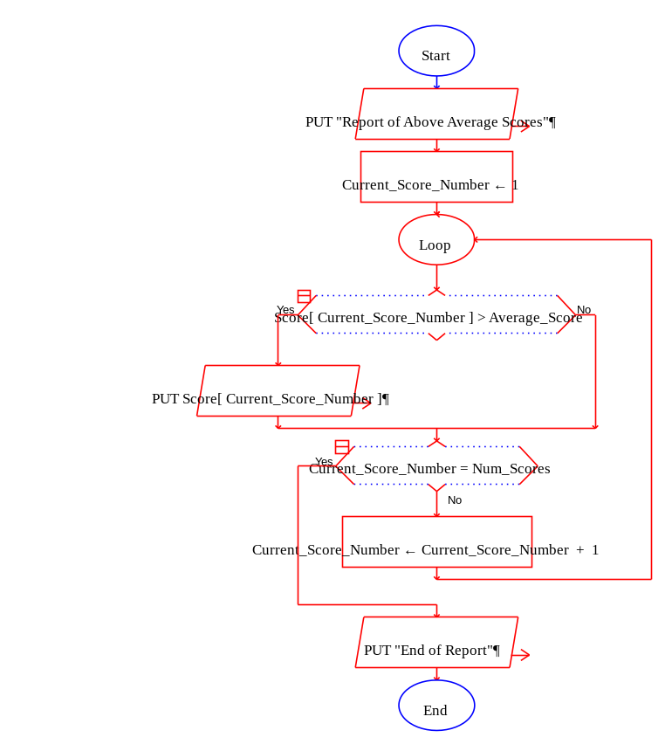

Another Example Extending the Idea of Functional Decomposition

Suppose you are newly assigned to an F-35 Lightning II squadron that is forward-deployed to a Middle-Eastern trouble spot. You have been tasked to assist the Mission Planner in preparing an attack on a munitions facility in close proximity to civilians and religious sites.

You could use your algorithmic thinking skills, including functional decomposition, to tackle this tough problem. Your top level (Main) process might look something like the process on the next page.

We now have an algorithm for accomplishing our task. Sure, there is more work to be done by further decomposing each sub-process. However, those can now be done in isolation so each is simpler. Furthermore, we can hand-off the various pieces (sub-processes) to experts in those areas.

In a real-world task such as this one you would probably not write a RAPTOR flowchart to document your approach to accomplishing this task, but problems like this will require you to use algorithmic thinking and reasoning skills to create appropriate solutions.
F-35 Mission Planning Algorithm
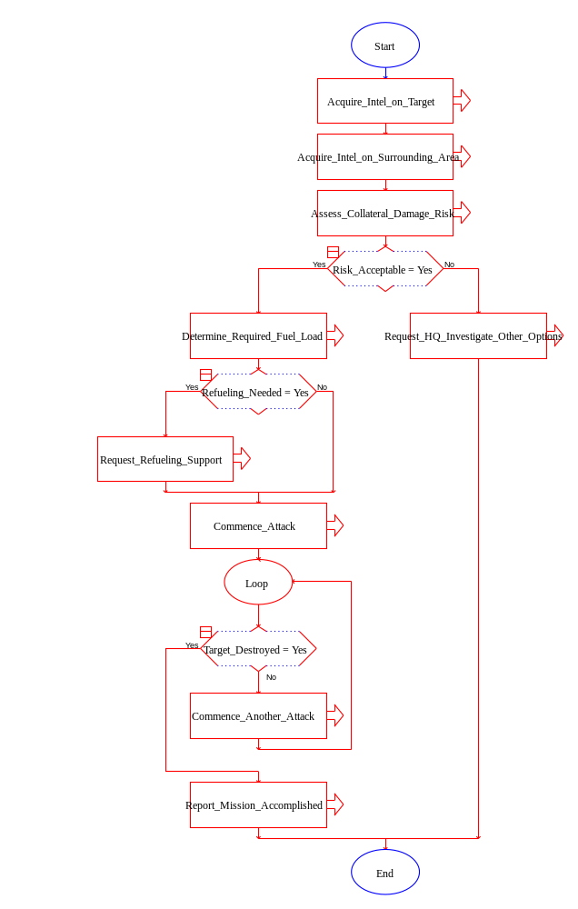

One More Functional Decomposition Example (Bouncing Balls)

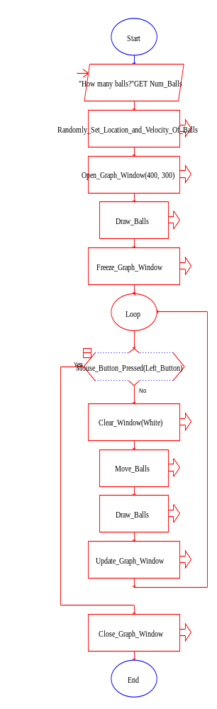
Let’s finish up with one more example of functional decomposition but this time with something fun – bouncing a bunch of balls around the screen. The flowchart to the right shows the top-level process for "Bouncing Balls".

This process is a bit complicated but not nearly as much as it would be if we did not use functional decomposition (as we’ll see in a bit). Note that the Draw_Balls sub-process is actually called in two places, but we only had to write it once. This is another great benefit of process abstraction.

We won’t show all of the sub-processes here (but you can get them from the course web site). However, let’s take a look at the Move_Balls process.

Move_Balls
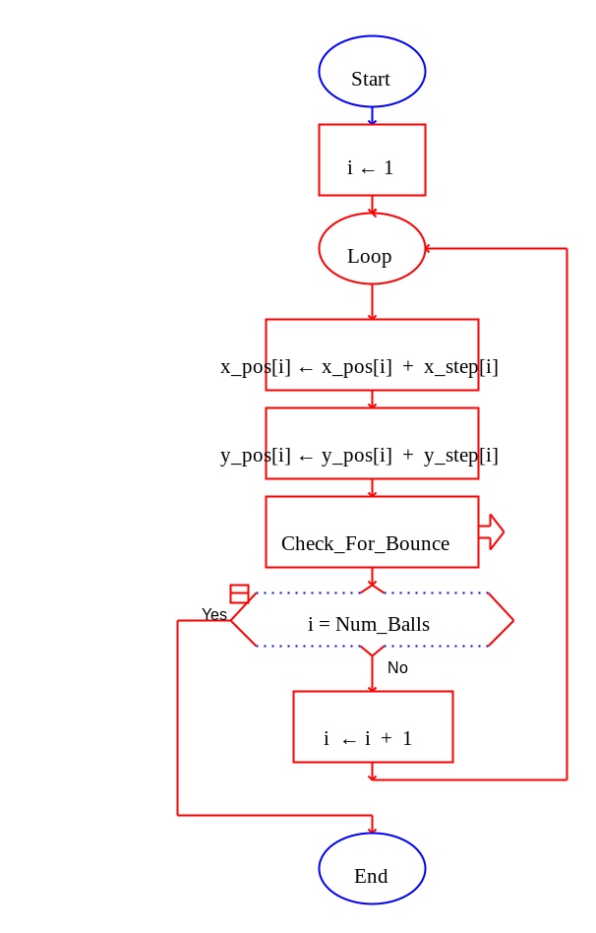

Here the need to bounce the balls from the walls is a bit complicated so we simply make it a separate sub-process which we can worry about later. Depending upon the complexity of the program / algorithm that we are designing, we could end up with many levels of sub-processes.

To emphasize how functional decomposition helps us to manage complexity, let’s compare the Bounce_Balls program above with one that does everything in a single process. See below for the YUCKY alternative. (Yes, “YUCKY” is a technical term in computer science ☺).

Bouncing_Balls_Yucky
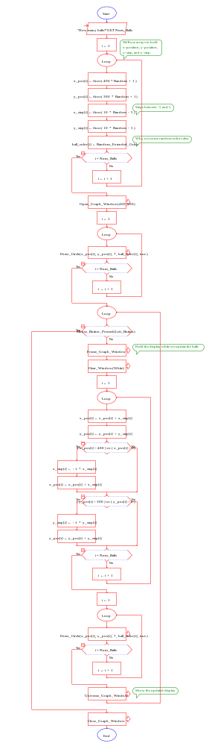

So, in conclusion, we hope that you have seen how decomposing a tough problem into smaller functional pieces and then addressing those pieces separately can help us deal with very complex problems. Indeed, functional decomposition is a very common technique for complex problem solving which is not limited to just computer programming. Furthermore, flowcharts (such as those we build in RAPTOR) are a great way to express our resulting processes. In fact, they are becoming the basis for many new programming environments such as IBM’s WebSphere and are used in some Air Force instructions to describe processes because they are very visual and easy to understand.

